**1.Create a project Jumphost instance**

* In the GCP Console go to Navigation Menu >Compute Engine > VM Instance.

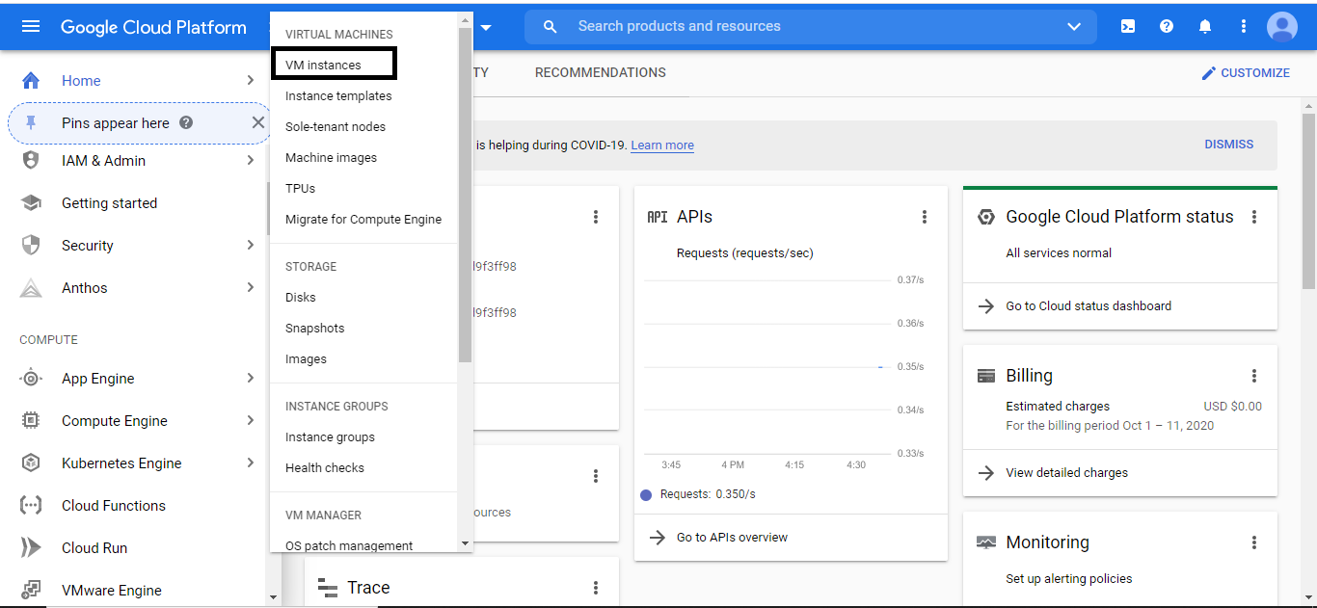

* Write the below parameters, check machine type, and Image type.
* The name of instance:  nucleus-jumphost
* Default region and zone
* The machine type be f1-micro series N1.
* default image type (Debian Linux)
* Click Create

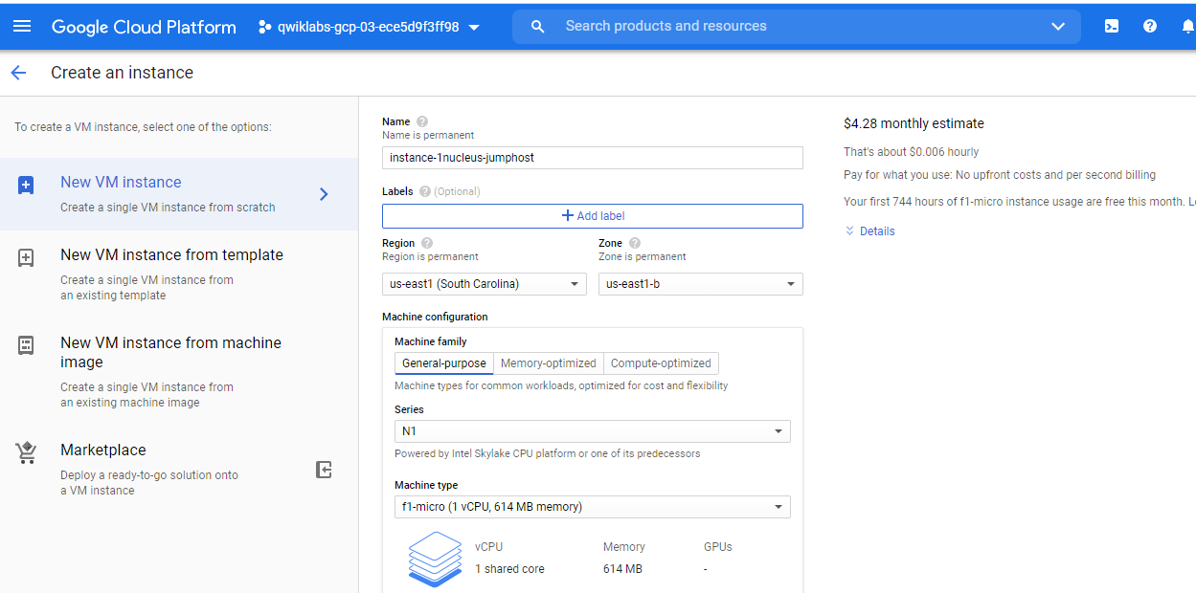

**Taskt-2:**

gcloud config set compute/zone us-east1-b

gcloud container clusters create nucleus-jumphost-webserver1

gcloud container clusters get-credentials nucleus-jumphost-webserver1

kubectl create deployment hello-app --image=gcr.io/google-samples/hello-app:2.0

kubectl expose deployment hello-app --type=LoadBalancer --port 8080

kubectl get service

**Task-3:**

**Step1:**

cat << EOF > startup.sh  
#! /bin/bash  
apt-get update  
apt-get install -y nginx  
service nginx start  
sed -i — ‘s/nginx/Google Cloud Platform — ‘“\$HOSTNAME”’/’ /var/www/html/index.nginx-debian.html  
EOF

**step-2**

gcloud compute instance-templates create nginx-template \  
--metadata-from-file startup-script=startup.sh

**step-3**

gcloud compute target-pools create nginx-pool

**step-4**

gcloud compute instance-groups managed create nginx-group \  
--base-instance-name nginx \  
--size 2 \  
--template nginx-template \  
--target-pool nginx-pool

gcloud compute instances list

**step-5**

gcloud compute firewall-rules create www-firewall --allow tcp:80

**step-6**

gcloud compute forwarding-rules create nginx-lb \  
--region us-east1 \  
--ports=80 \  
--target-pool nginx-pool

**step-7**

gcloud compute forwarding-rules list

**step-8**

gcloud compute http-health-checks create http-basic-check

gcloud compute instance-groups managed \  
set-named-ports nginx-group \  
--named-ports http:80

**step-9**

gcloud compute backend-services create nginx-backend \  
--protocol HTTP --http-health-checks http-basic-check --global

gcloud compute backend-services add-backend nginx-backend \  
--instance-group nginx-group \  
--instance-group-zone us-east1-b \  
--global

**step-10**

gcloud compute url-maps create web-map \  
--default-service nginx-backend

gcloud compute target-http-proxies create http-lb-proxy \  
--url-map web-map

**step-11**

gcloud compute forwarding-rules create http-content-rule\  
--global \  
--target-http-proxy http-lb-proxy \  
--ports 80

gcloud compute forwarding-rules list